**LAPORAN**

Lagrange Method Program in C++



**Steven Cuaca 20165520019**

**Jevon Adriel 20165520001**

**Nicholas Suryawan 20165520028**

**PROGRAM STUDI TEKNIK INFORMATIKA**

**FAKULTAS SAINS, TEKNOLOGI, TEKNIK, DAN MATEMATIKA**

**TANGERANG**

**2018**

**Soal:**

Given the data points (0,2), (1,3), (3,3), and (4,5). Apply Lagrange Method to find interpolation polynomial passing through these points.

**Solution:**

Using C++ program.

*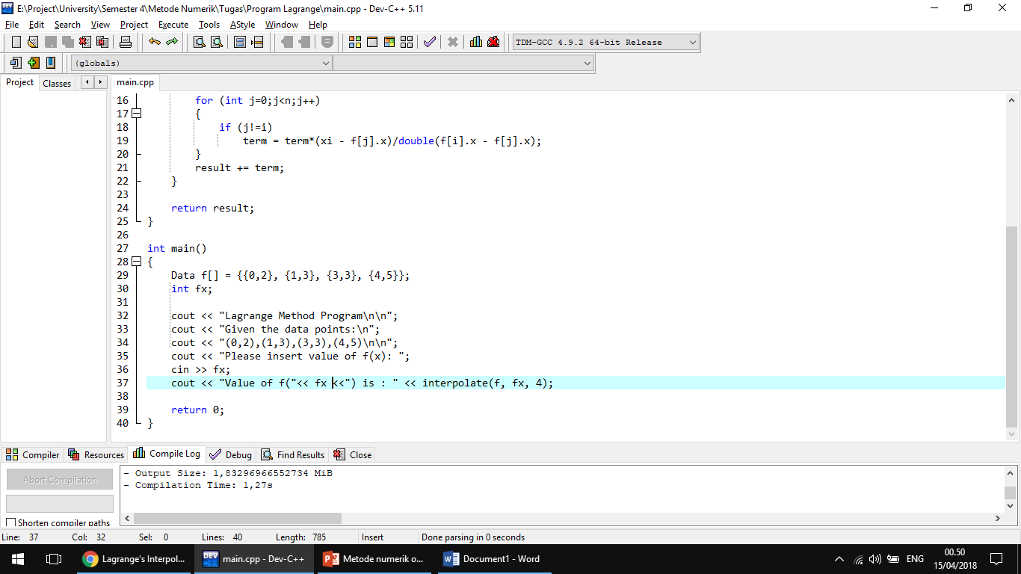Source Code Program*

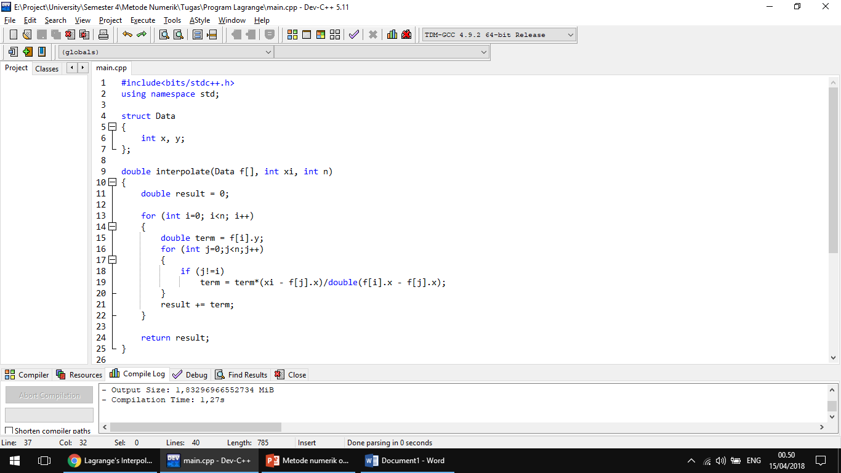

*Output Program*

1. f(x) → f(2)

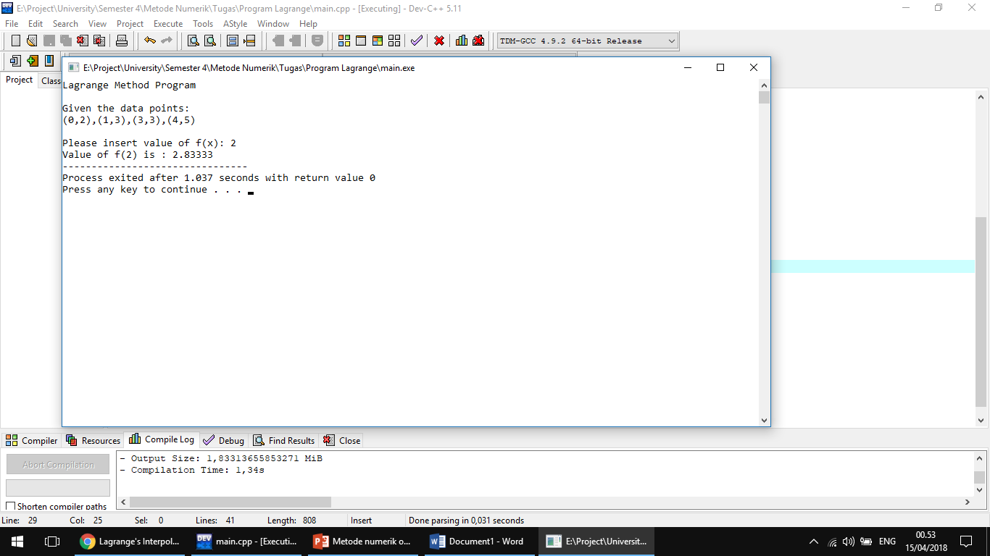

1. f(x) → f(5)

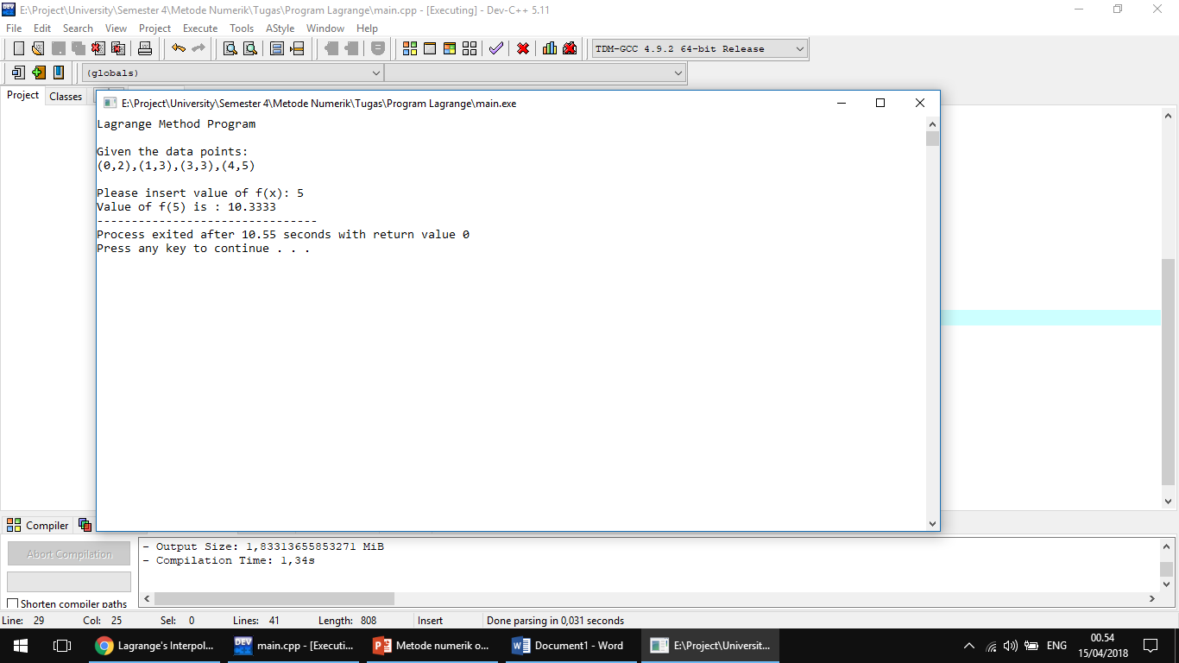

1. f(x) → f(10)

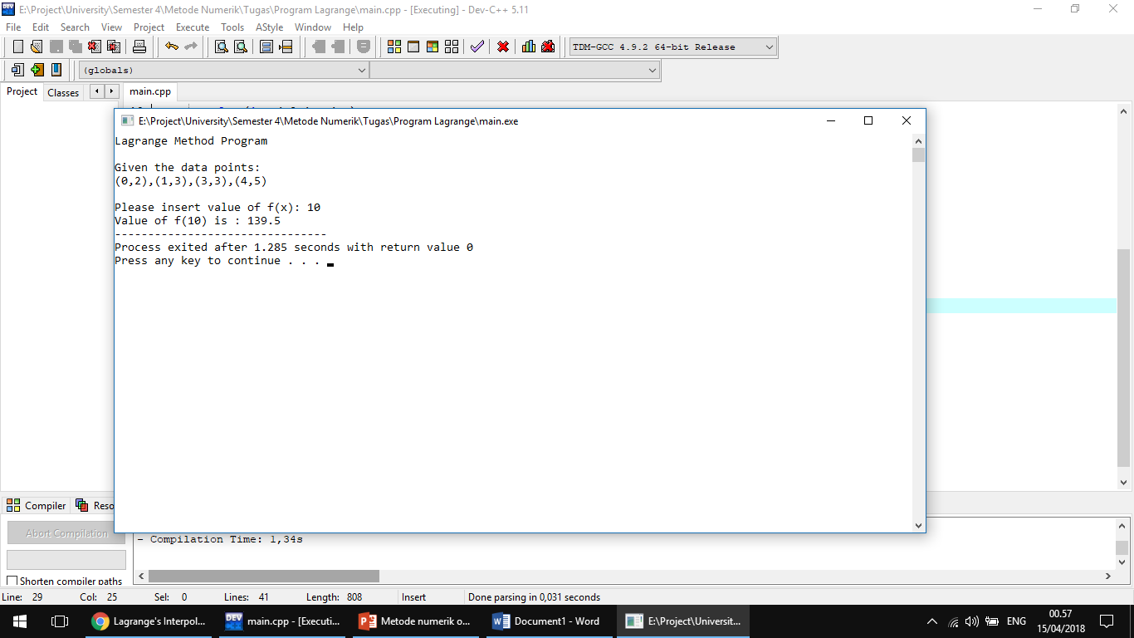

Source Code: https://goo.gl/SrhXN3